Appearance and Layout updates:
Theme, Top Bar, Link Bar and Footer

Theme/Appearance

Fonts (unless otherwise specified)

General text, field labels: Open Sans
-fallback: open sans, helvetica neue, helvetica, arial, sans-serif

Headers, title bars, buttons: Verdana
-fallback: Verdana, Geneva, sans-serif

Color scheme
Blue:
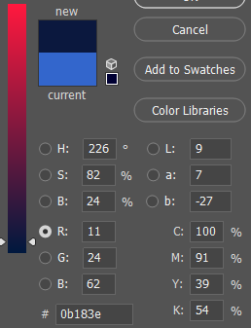

Gold:
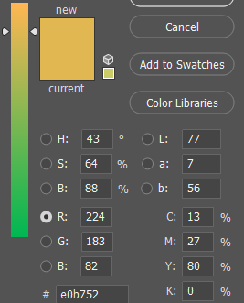

Table Lines:
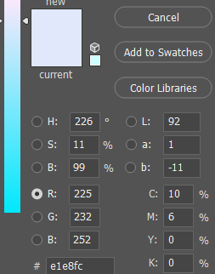

Top Bar
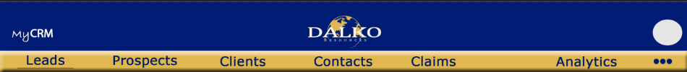

Adjust the layout and color of the Top bar
*Add the wording MyCRM to the top left
-white font, bold
-Font for “My” is Bradley Hand ITC
-Font for “CRM” is Myriad Pro
*update the logo and center align it
*remove the username displayed beside the user menu
*add hover text to the user menu that displays the user’s name

Link Bar
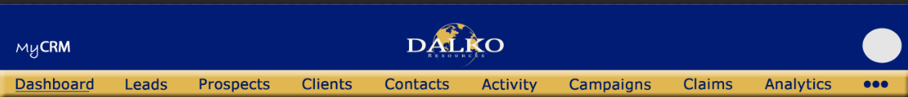

*change the color scheme and the order of the menu options, use image above as reference
*font = Verdana
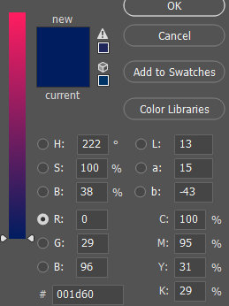

*the in-focus link indicator should be a bold line


*change the more menu to be represented as the three dot more menu style (see image)
-hover text: “More Options”
*Change “Lead” to “Leads”
*Add Prospects
*change “Customer” to “Clients”
*change “Contact” to “Contacts”
*change “Campaign” to “Campaigns”
*change “Help Desk” to “Claims”
*remove Product
*move the following under the More menu
- Enquiry
- Feeds
- Survey

Footer


*change the footer so it is not static but instead always at the bottom of the page
-the user will not see it until they have scrolled all the way to the bottom of the screen

